IVR SOLUTION PACKAGE FOR 1-YEAR

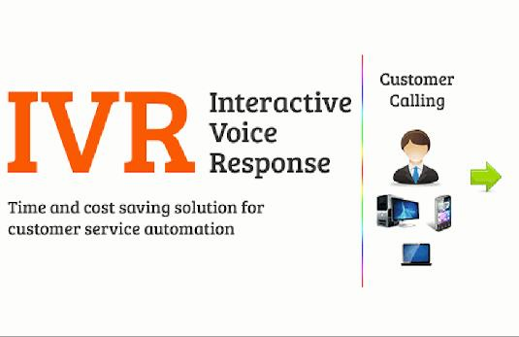PACKAGE COST @
₹15,000/-

- CALL LIMITS - 11000 FREE MINUTES

- Post Consumption Charges 15paisa/ 15seconds.

- SMS - 4000 FREE SMS

- (Post Consumption Charges 10paisa/ SMS).

- GST - 18 % EXTRA

- Others – Rs. 1000/- for Voice Recording.

ABOUT US
Hello IVR is One of the Best IVR Solutions Provider in Odisha,Bhubaneswar,India and Brand Service of Samaresh Web Solutions Pvt Ltd.

It enables you to effectively track, retain and push leads or enquiries through a pre-defined route.

Hello IVR Significantly increases first contact resolutions and customer services efficiency. We Can Provide you IVR Number of any state within INDIA or any other Country in the World at most affordable rates.

Our IVR (Interacting Voice Response) systems have been installed in numerous BPOs, Small, Medium & Large companies, Educational institutes, Construction Companies, etc.

IVR acts as a reception hosted virtually in a cloud telephony environment. We provide a 10 Digit mobile number or a landline number, on which the customers can call 24×7.

The customers are greeted with a customised message as per your requirements and can select the extension pre-defined by you to speak with the concerned team member or leave a voice mail.

At a low price, you can project the image of a professional company and would never have to worry about losing important leads.

Please find herewith business proposal for IVR

IVR Services

- Best Rate – Rs.15,000 Only /- ( For One Year with number )

- Call Limit – 11000 Free Min For One Year (Post Consumption Charges 15paisa/15seconds.

- SMS – 4000 Free SMS For One Year (Post Consumption Charges 10paisa/SMS).

- GST – 18% Extra

- Others – Rs. 1000/- for Voice Recording.

IVR FEATURES LIST
  - All incoming calls on the IVR number are greeted with a welcome tone and integrated voice message like “Welcome to ABC Pvt. Ltd please wait while we connect your call to our representative”. Now, there are two option of the call forwarding:

Direct call forwarding.

    - DTMF (Dual-tone multi-frequency) Service:

>> PRESS-1 for Sales department,
>> PRESS-2 for admin department etc.

  - You can make your own mobile number/ toll free number as a virtual number and map executives to it.

  - You can add ‘n’ number of executive against a Virtual Number.

  - No Call Drop.

  - You will get Call tracking panel to track inbound calls.

  - You can set call pick priority according to you for Sales Team.

  - You can provide access to your executive also, so that they can see their own call record.

  - You can access your call tracking panel anywhere any time online.

  - 100% voice recording of each picked call with play/download option.

  - User Friendly Control Panel.

  - 2-way prompt sms. After conversations both executive and client gets the message

mobile number of each other.

  - You can download reports into excel from panel.

  - Showing name and Stick Agent Facility also available.

  - 100% data security.

Demo Panel Details:

URL : www.apps.helloivr.in UserName : demo@helloivr.in Password : qwerty

Samaresh Web Solutions Pvt Ltd is pleased to submit the proposal for all of our services.
For Further Queries, Please Feel Free To Contact:
Contact Name : Samaresh Bisoi
Mobile Number: +91-8018202486

BANK DETAILS
ICICI Bank
Samaresh Web Solutions Pvt. Ltd Account No : 006105023838 IFSC Code : ICIC0000061

